Thought Starter: How can we look after energy resources for the future?

Renewable and Non-Renewable Resources

You will now work in your pairs to order the following resources according to their regeneration rates. You can do this by adding a number from 1 to 5 (with 1 being the fastest) next to each resource. You should also decide whether each of these resources is renewable or non-renewable and why.

|  |  |  |
| --- | --- | --- |
| **Resource** | **Regeneration Rate (number from 1 to 5, with 1 being the fastest)** | **Do you think this is a renewable or non-renewable resource? Explain your answer:** |
| Coal |  |  |
| Wood |  |  |
| Eggs |  |  |
| Water |  |  |
| Sunlight |  |  |

Renewable Energy

**1.** Look at this image of different types of renewable energy. Can you identify them? What do you already know about these energy types?

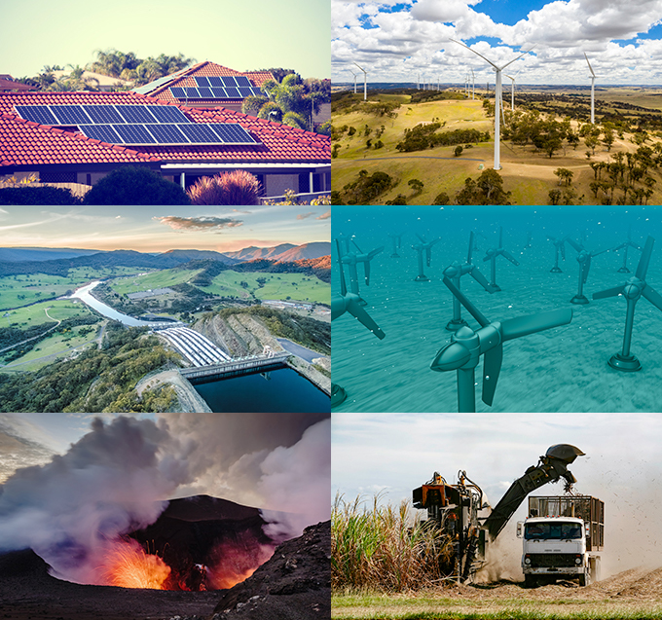

**2.** Working in pairs you now need to generate questions based on the following statement:

* What I DON’T know about renewable energy.

Each pair of students needs to generate at least five questions that they think they could answer through online research and record these below:

1.

2.

3.

4.

5.

Beyond The Science

**1.** Read the following:

*The renewable energy solutions you have just looked at have been developed as a way to find more sustainable forms of energy, particularly in terms of environmental sustainability. From the time of the Industrial Revolution, most energy generation relied on fossil fuels (fossil fuels are natural fuels that were formed in the geological past from the remains of living organisms). The role that energy generation from fossil fuels has played in our modern lives should not be understated; almost all of the things we do and use have their roots in energy sourced from fossil fuels. The problem is, burning fossil fuels to power our modern lives has a range of environmental impacts, including creating greenhouse gases that contribute to climate change, and the pollution of and disruption to both terrestrial and aquatic environments. Most forms of renewable energy generally have a much lower environmental impact.*

*Science has had a crucial role to play in helping us to understand the environmental impacts of our energy use as well as identifying and developing alternative solutions. But these solutions rely on people like us to take them up. In the next part of this lesson, you will be looking at some of these solutions.*

**2.** You will now work in groups to research and present other community renewable energy projects from around Australia and the world.

Below are some examples of community energy projects:

* [Open District Heating](https://www.opendistrictheating.com/)
* [Solar gardens](https://enovaenergy.com.au/solar-garden/)
* [Hepburn Wind](https://www.hepburnwind.com.au/about/)

Each group needs to research and compare these three examples, recording their results in the table below (or create your own):

|  |  |  |  |
| --- | --- | --- | --- |
|  | **Open District Heating** | **Solar gardens** | **Hepburn Wind** |
| Is the source of energy in this case study renewable? |  |  |  |
| What information can you find about the science involved in this case study? |  |  |  |
| How are the community involved in this project? |  |  |  |
| What do you find interesting or inspiring about this case study? |  |  |  |

Reflection

Work independently to think about what you looked at in this lesson and complete the following:

What I used to think…

What I now think…